Code of practice

Psychosocial hazards in the workplace

Foreword
This code of practice is issued by the Commission for Occupational Safety and Health (the Commission), under provisions of the Occupational Safety and Health Act 1984 (the OSH Act). The introduction of the OSH Act enabled the establishment of the Commission. It comprises representatives of employers, unions and government, as well as experts, and has the function of developing the occupational safety and health legislation and supporting guidance material, and making recommendations to the Minister for Mines and Petroleum; Commerce and Industrial Relations for their implementation. To fulfil its functions, the Commission is empowered to establish advisory committees, hold public inquiries and publish and disseminate information.
The Commission’s objective is to promote comprehensive and practical preventive strategies that improve the working environment of Western Australians. This code of practice has been developed through a tripartite consultative process and the views of employers and unions, along with those of government and experts have been considered.

Legislative framework for occupational safety and health

Occupational Safety and Health Act 1984
The OSH Act provides for the promotion, co-ordination, administration and enforcement of occupational safety and health in Western Australia. It applies to all workplaces with the exception of mining and petroleum. With the objective of preventing occupational injuries and diseases, the OSH Act places certain duties on employers, employees, self-employed people, manufacturers, designers, importers and suppliers. These broad duties are supported by further legislation, commonly referred to as regulations, together with non-statutory codes of practice and guidance notes.

Occupational Safety and Health Regulations 1996
The Occupational Safety and Health Regulations 1996 (the OSH Regulations) set out specific requirements of the legislation. They prescribe minimum standards and have a general application, or define specific requirements related to a particular hazard or type of work. They may allow licensing or granting of approvals and certificates. If there is a regulation about a risk in the OSH Regulations, it must be complied with.

Codes of practice
Codes of practice published under the OSH Act provide practical guidance on how to comply with a general duty or specific duties under the legislation. Codes of practice may contain explanatory information. However, the preventive strategies outlined do not represent the only acceptable means of achieving a certain standard.
A code of practice does not have the same legal force as a regulation and is not sufficient reason, of itself, for prosecution under the legislation, but it may be used by courts as a standard when assessing other methods or practices used.
If there is a code of practice about a risk, either:
do what the code of practice says, or
adopt and follow another way that gives the same level of protection against the risk.
If there is no regulation or code of practice about a risk, choose an appropriate way and take reasonable precautions and exercise proper diligence to ensure obligations are met.
Note: There may be additional risks at the workplace not specifically addressed in this code of practice. The OSH Act requires identification and assessment of them and implementation of control measures to prevent or minimise risk.

Scope
The code focuses on the general principles applied to the prevention and management of psychosocial hazards in the workplace. The intent of this code of practice is to provide practical guidance for workplaces where workers may be exposed to psychological and social hazards such as inappropriate behaviours, violence and aggression, and fatigue, stress and trauma, which can be harmful to their health.
The guidance in this code of practice should be considered in conjunction with the general duties in the OSH Act 1984 and with the guidance provided in the Workplace behaviours and the Violence and aggression at work codes of practice.

Who should us this code of practice?
Everyone who has a duty to prevent, so as far as practicable, hazards at workplaces should use this code. This includes employers, employees, self-employed people, safety and health representatives and safety and health committees.
This code is intended to be read by employers and those who have duties under the OSH Act. It provides practical guidance on the process an employer could use to identify and to manage psychosocial hazards at work. You should use this code of practice if you have functions or responsibilities that involve managing, so far as is reasonably practicable, exposure to psychosocial hazards and risks to psychological and physical health and safety at work.
The code may also be a useful reference for other persons interested in complying with the duties under the OSH Act and OSH Regulations.

Using this code of practice
The terms used in this code of practice are intended to have a broad and flexible application, for use across all Western Australian workplaces covered by the OSH Act. The term workplace usually means the physical location where someone works, including working at home or away from home. The code of practice provides high-level guidance for a risk management approach, which should be tailored to the unique demands of each workplace.
Managing psychosocial hazards and risks can be challenging because of the complex interplay and changing nature of risks. Effective consultation and communication are critical, and a proactive and integrated approach is required.
The code of practice includes references to both mandatory and non-mandatory actions. The words “must” or “requires” indicate that legal requirements exist, which must be complied with. The word “should” indicates a recommended course of action, while “may” is used to indicate an optional course of action.

Contents
Foreword 2
Legislative framework for occupational safety and health 2
Scope 2
Who should us this code of practice? 3
Using this code of practice 3
1 Introduction 5
1.1 Psychosocial hazards at work 5
1.2 Legislative context 5
1.3 Work-related psychosocial hazards and risk factors 6
2 Overview of risk management approach 11
2.1 Risk management process 11
2.2 Communication and consultation 11
2.3 Applying the hierarchy of control to psychosocial hazards and risk factors 12
3 Leadership and workplace culture 13
3.1 Demonstrating commitment 13
3.2 Supportive and capable management and supervision 13
3.3 Training and education 13
4 Identifying psychosocial hazards and risk factors 15
4.1 Identification approaches 15
5 Assessing the risks 16
5.1 Assessment approaches 16
6 Risk control strategies 18
6.1 Control measures for psychosocial hazards 18
6.2 Eliminate or minimise risk through good work design 18
6.3 Minimise risk through safe Systems of work 18
6.4 Implementing controls 19
7 Review 21
9 Responding to worker reports 22
Appendix 1 Legislative provisions 23
Occupational safety and health legislation 23
Occupational Safety and Health Act 1984 23
Occupational Safety and Health Regulations 1996 23
Other legislation to consider 23
Appendix 2 Examples of risk management in various workplaces 24
Hazard identification and risk assessment form (small – service/retail) 25
Hazard identification and risk assessment form (medium – medical centre) 27
Hazard identification and risk assessment form (medium – automotive workshop) 30
Hazard identification and risk assessment form (large – State Government department) 32

1 Introduction

1.1 Psychosocial hazards at work
Workplace psychosocial hazards are related to the psychological and social conditions of the workplace rather than just the physical conditions. These include stress, fatigue, bullying, violence, aggression, harassment and burnout, which can be harmful to the health of workers and compromise their wellbeing (Figure 1.1).
Both short- and long-term exposure to psychosocial hazards may cause harm to a person. For example, while exposure to severe, short-lived (acute) psychosocial hazards such as experiencing violence at work may result in harm to health (e.g. acute-stress disorder, post-traumatic stress disorder), it is important to also recognise that the cumulative effect of low-level exposure to psychosocial hazards can also lead to psychological or physical injury. People may experience multiple psychological and physical symptoms of harm as a result of exposure.
Note: If there has been harm to health arising from exposure to workplace psychosocial hazards and risk factors that meets the criteria for reporting, it must be reported to the regulator.
In addition to adverse health outcomes for workers, exposure to psychosocial hazards and risk factors in the workplace can also affect performance and increase the risk of accidents or incidents.
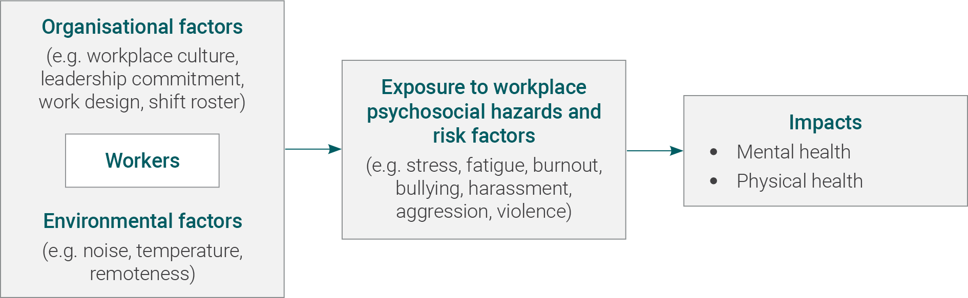
Figure 1.1 Diagram showing the influence of workplace conditions on workers’ health

1.2 Legislative context

Employer Duties
The OSH Act requires an employer to ensure, so far as is reasonably practicable, the health and safety of workers while at work. ‘Health’ includes both physical and psychological health.
An employer must ensure, so far as is reasonably practicable, workers and other people are not exposed to risks to their psychological health and safety. An employer must eliminate psychosocial risks in the workplace, or if that is not reasonably practicable, minimise these risks so far as is reasonably practicable.
Employers (including principal contractors and labour hire agents) must report certain injuries or diseases to WorkSafe including any fracture, amputation or other injury, which, in the opinion of a medical practitioner, requires 10 or more days of lost time at work.

Worker and others duties
The Act also contains general duties and responsibilities placed upon people to ensure their own safety at work, and that of others who are at the workplace or who might be injured by the work. Workers and other persons must comply with reasonable health and safety instructions, as far as they are reasonably able, and co operate with reasonable health and safety policies or procedures that have been notified to workers.

Consultation
Employers must consult and cooperate with safety and health representatives (if any) and employees about safety and health at the workplace, under the general duty of care provision, section 19(1)(c) of the OSH Act.

1.3 Work-related psychosocial hazards and risk factors
Workers are likely to be exposed to a combination of work-related psychosocial hazards and risk factors. Some are always present, and others occasionally, therefore it is important to consider both in the risk management process.
Table 1.1 lists some psychosocial hazards and risk factors that employers should assess as part of the risk management process. The list is not exhaustive and there are other psychosocial hazards and risk factors that an employer may need to consider.
Table 1.1. Examples of work-related psychosocial hazards and risk factors.
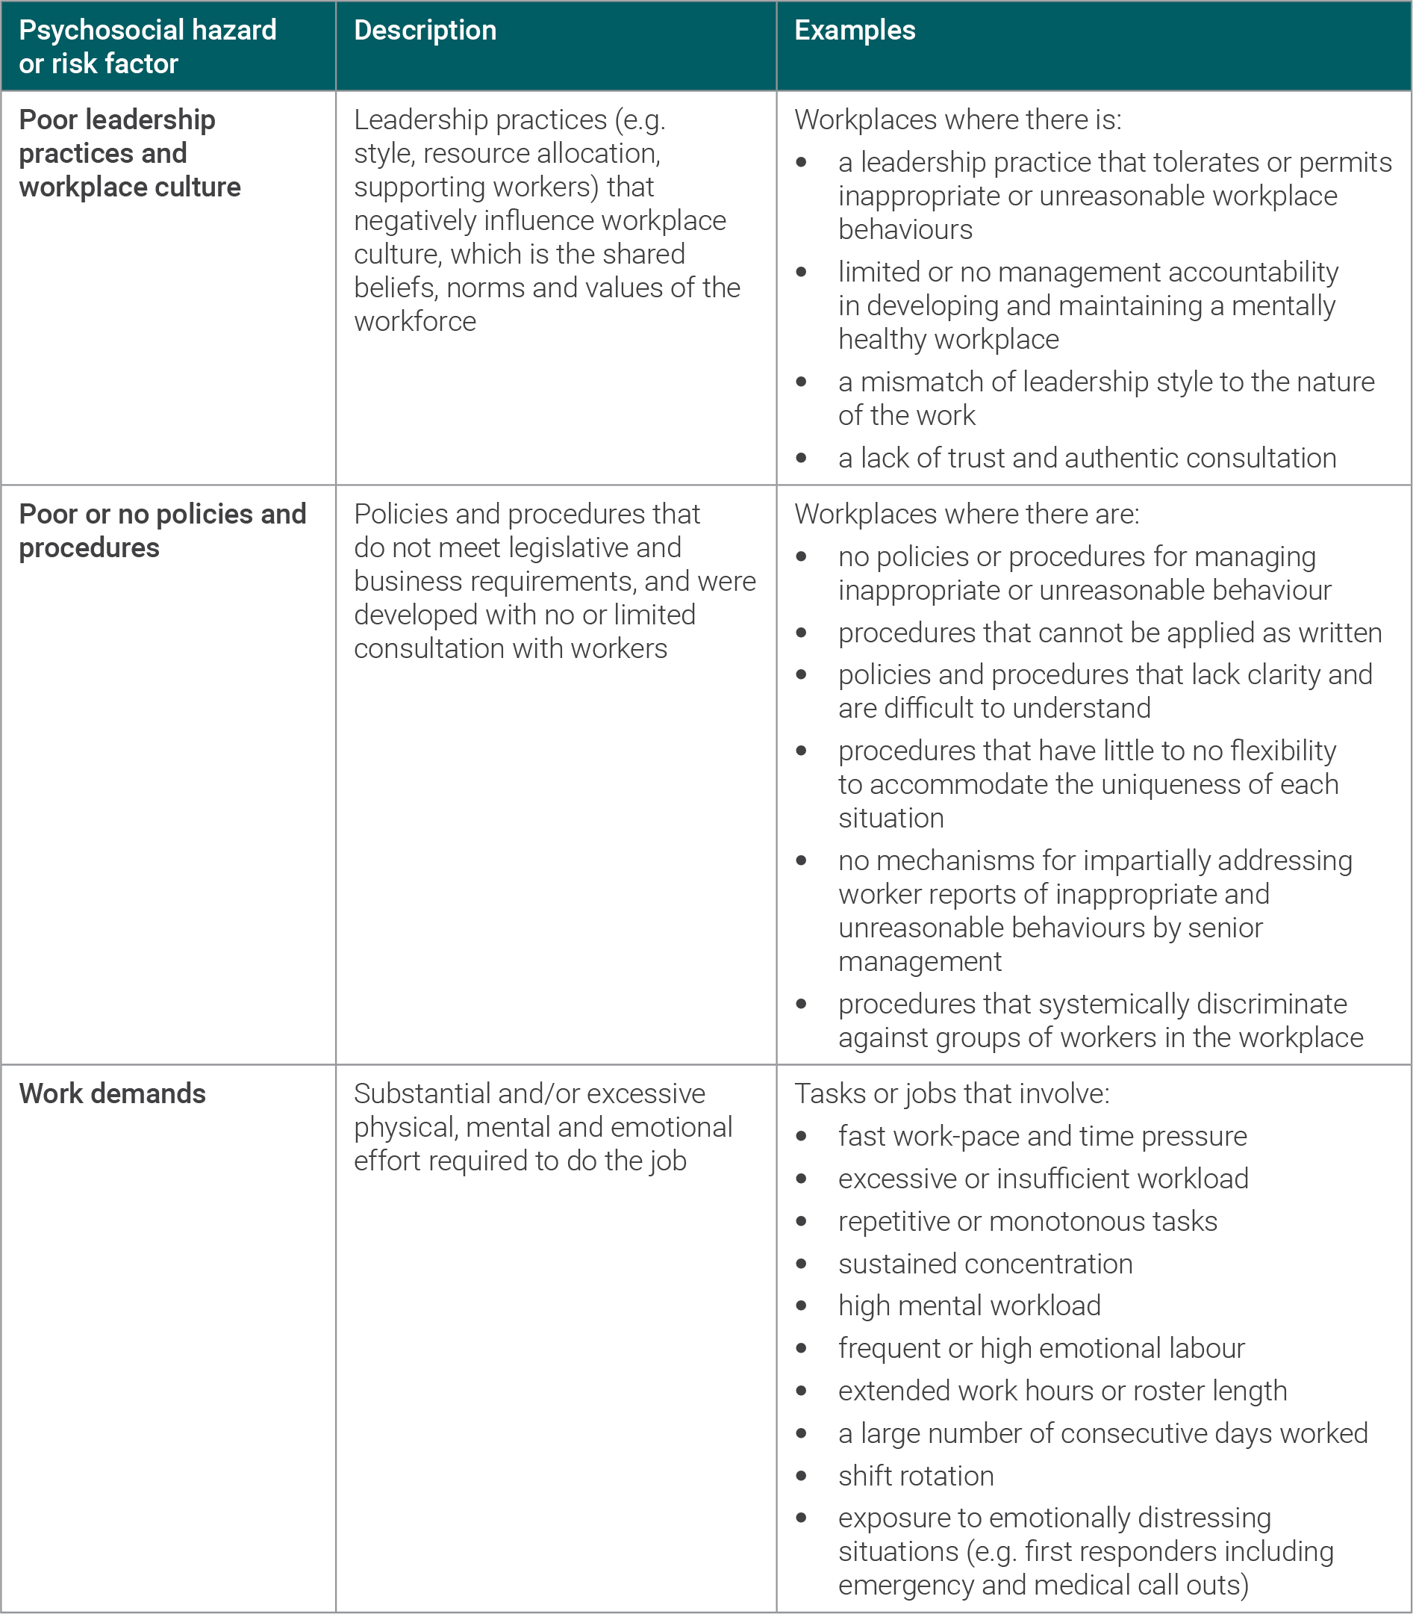
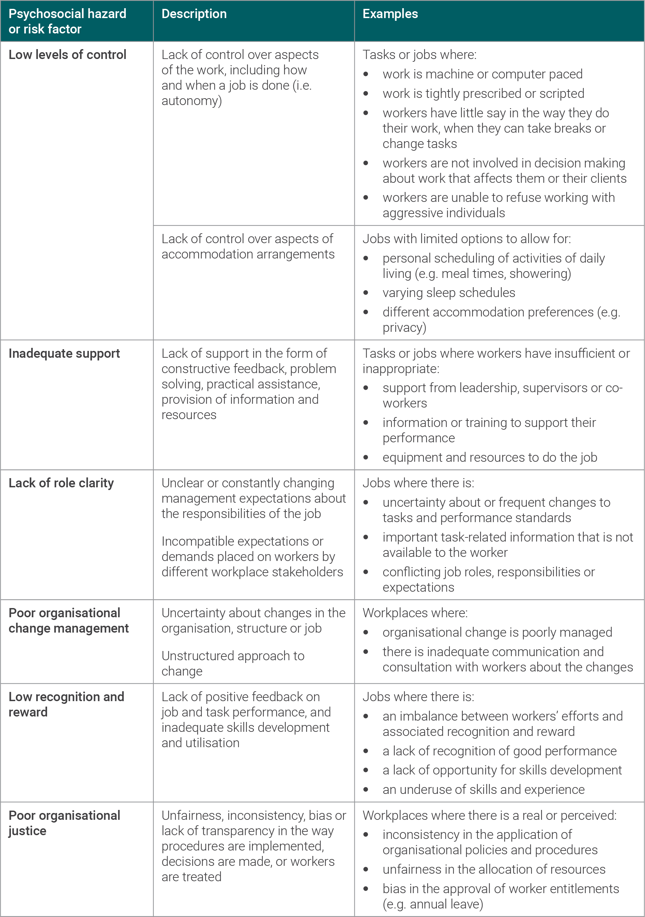

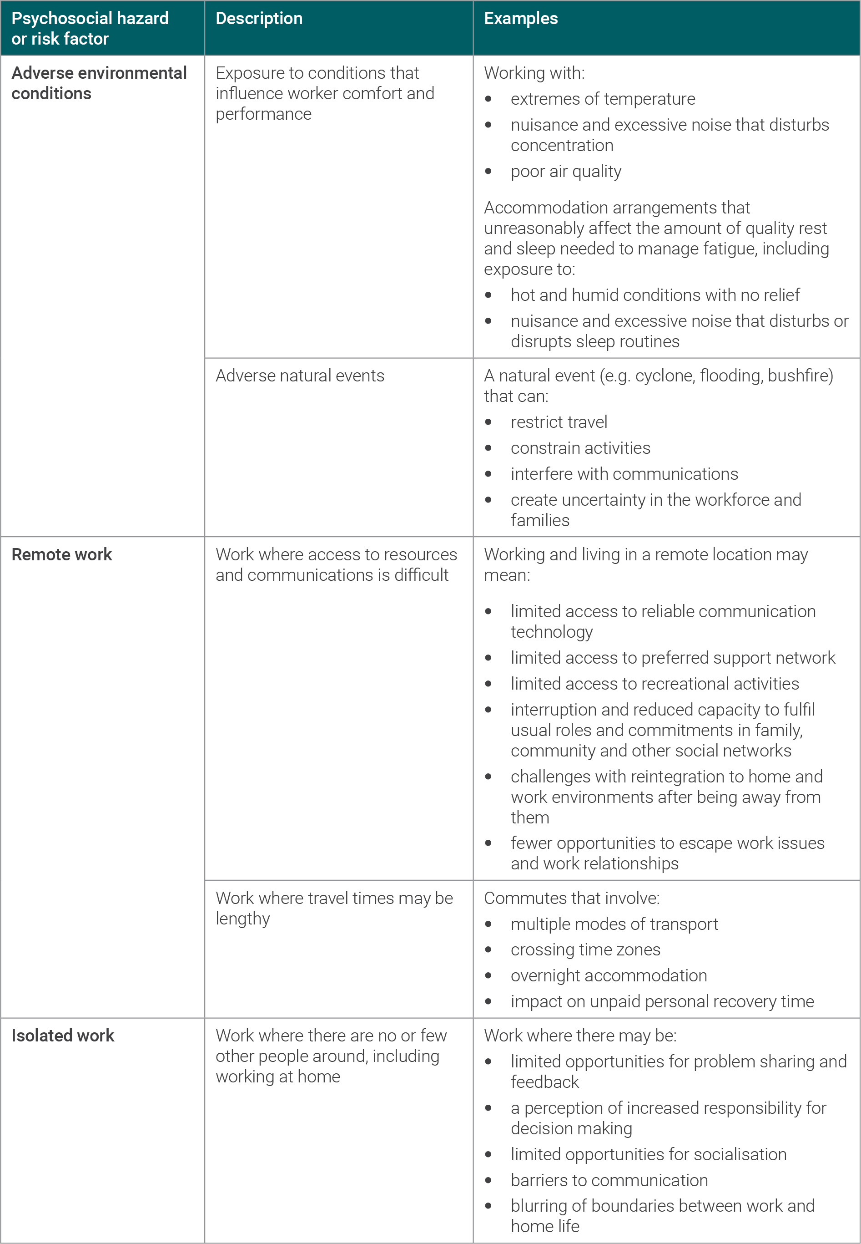

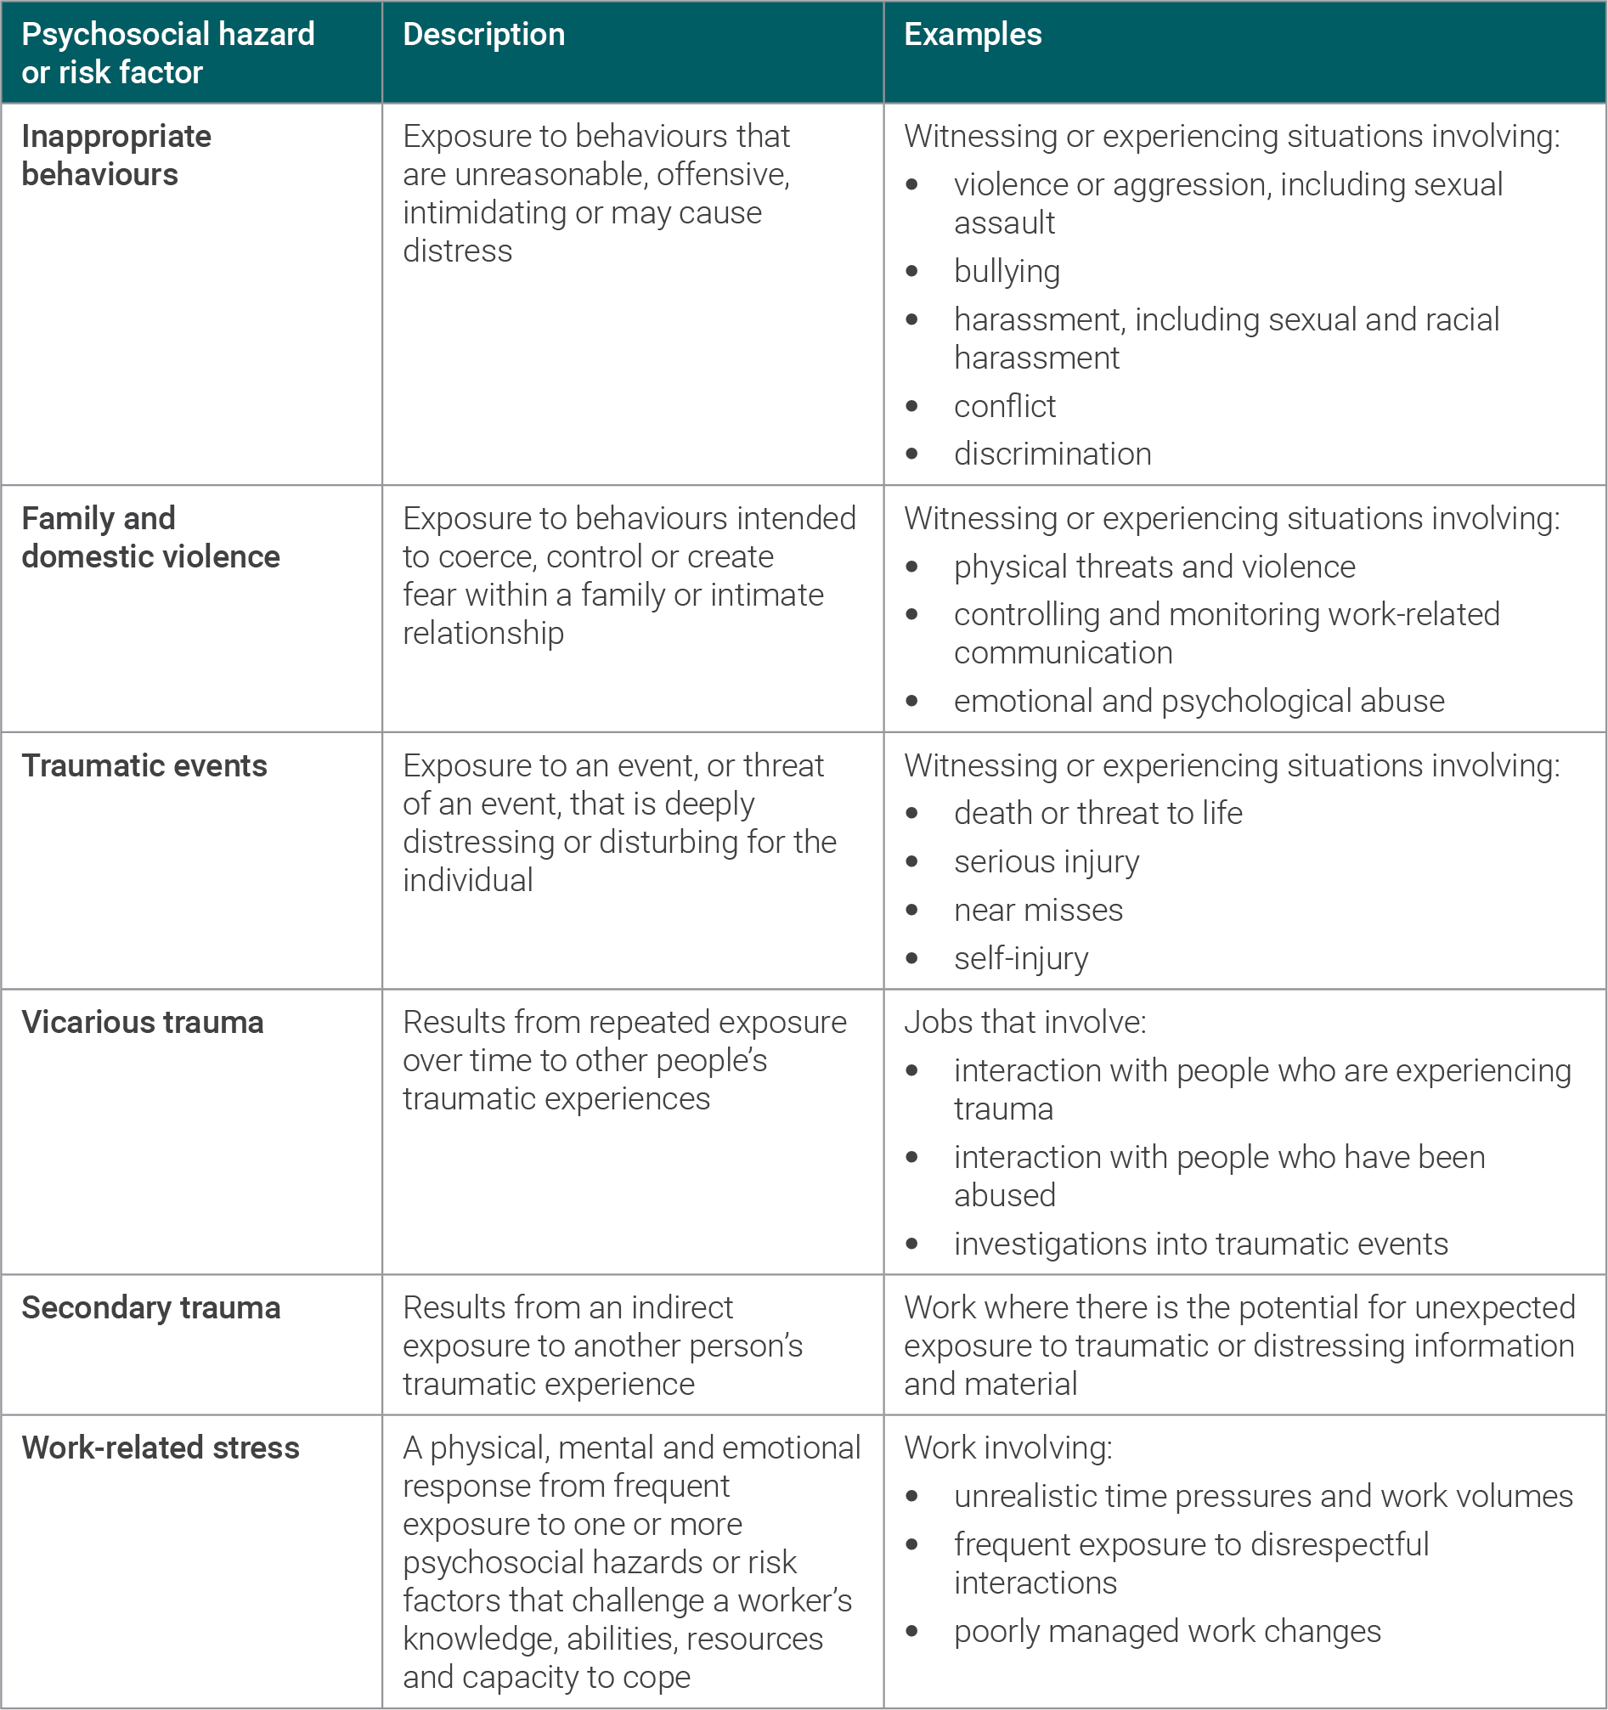

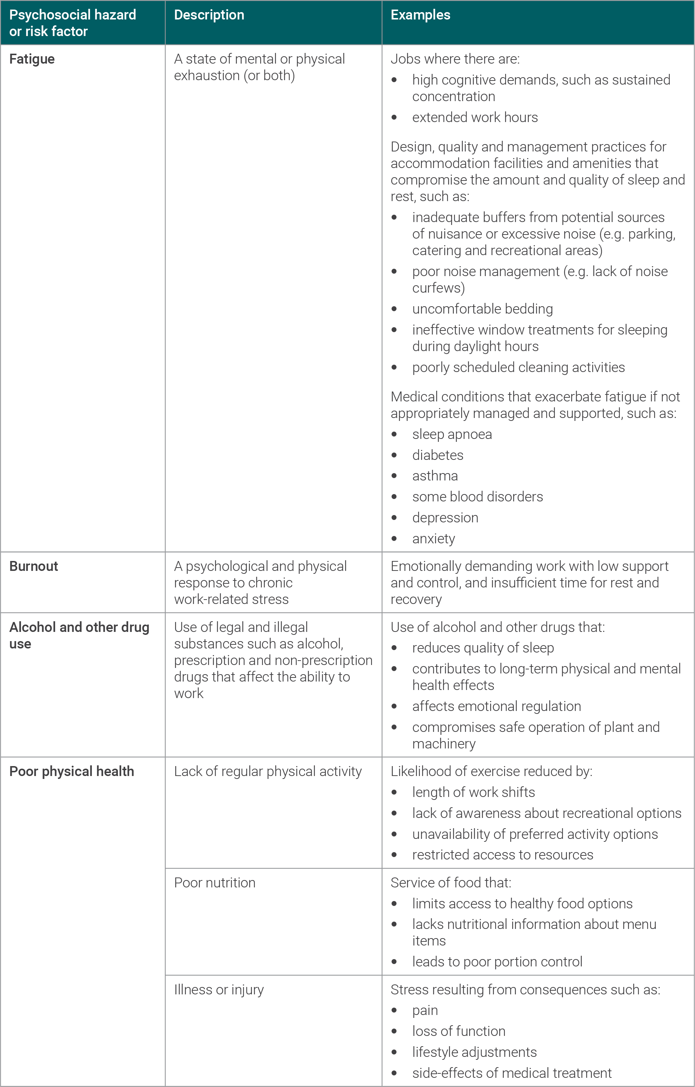

2 Overview of risk management approach

2.1 Risk management process
To meet your duties to manage psychosocial risk, you must eliminate or minimise the risk so far as is reasonably practicable. To achieve this, just as for any other hazard, you can apply the risk management process.
Figure 2.1 illustrates the risk management approach for psychosocial hazards and risk factors:
- identify the psychosocial hazards and risk factors
- assess the risks
- control the risks by making the changes necessary to eliminate the hazards or risk factors or, if not practicable, minimise the risk of harm
- monitor and review the effectiveness of the controls.
Leadership commitment, as well as supportive and capable management and supervision, are key to the successful management of risks. Communication and consultation are important at all stages.
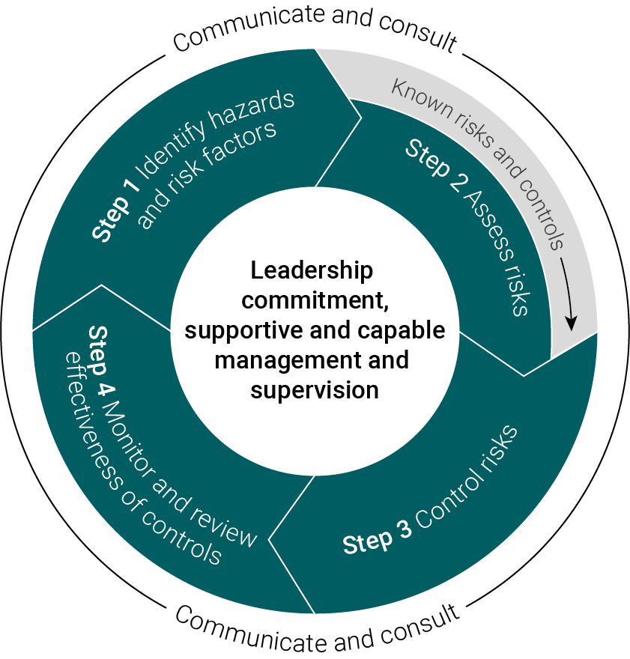
Figure 2.1 Overview of the risk management process (adapted from Safe Work Australia, 2018). Where the risks associated with a hazard are known, recognised controls can be applied directly.

2.2 Communication and consultation
Effective communication requires consistent and authentic engagement, action and feedback from management to address workforce concerns. This means sharing information with workers and giving them a reasonable opportunity to express their views on safety and health matters that may affect them.
Consultation with workers and safety and health representatives is important at each step of the risk management process. By drawing on workers’ experience, knowledge and ideas, it is more likely that psychosocial hazards and risk factors will be identified and effective controls selected. Worker participation throughout the process can lead to increased support and understanding when strategies are implemented.
Examples of strategies to encourage communication and reporting include:
- modelling of desired behaviours and values by managers and supervisors
- actively encouraging workers to provide feedback
- consulting workers about workplace updates and changes
- being responsive to worker reports
- empowering a safe, supportive and learning culture
- checking in regularly with workers
- maintaining confidentiality.
Examples of activities to support effective communication and consultation include:
- using focus groups
- having a standing agenda or discussion item at
  - safety and health committee meetings
  - team meetings
  - toolbox meetings
- regular updates to the workforce (e.g. email broadcasts, newsletters).

2.3 Applying the hierarchy of control to psychosocial hazards and risk factors
Some psychosocial hazards and risk factors relate to the job as a whole, such as organisational change or workplace conflict, whereas others may be relevant to some tasks. To address this, a systematic approach is required to achieve effective control.
Some controls are more effective than others. They can be ranked from the highest level of protection and reliability to the lowest. This ranking is known as the hierarchy of control (Figure 2.2). Elimination controls are the most effective and reliable form of control, followed by risk minimisation controls (engineering, substitution and isolation) then administrative and personal protective equipment (PPE) controls.
To minimise the risk to as low as reasonably practicable, employers should apply elimination controls supplemented by risk minimisation and administrative and PPE controls.
Employers should focus on workplace sources of risk that are within their influence, such as organisational and environmental factors.

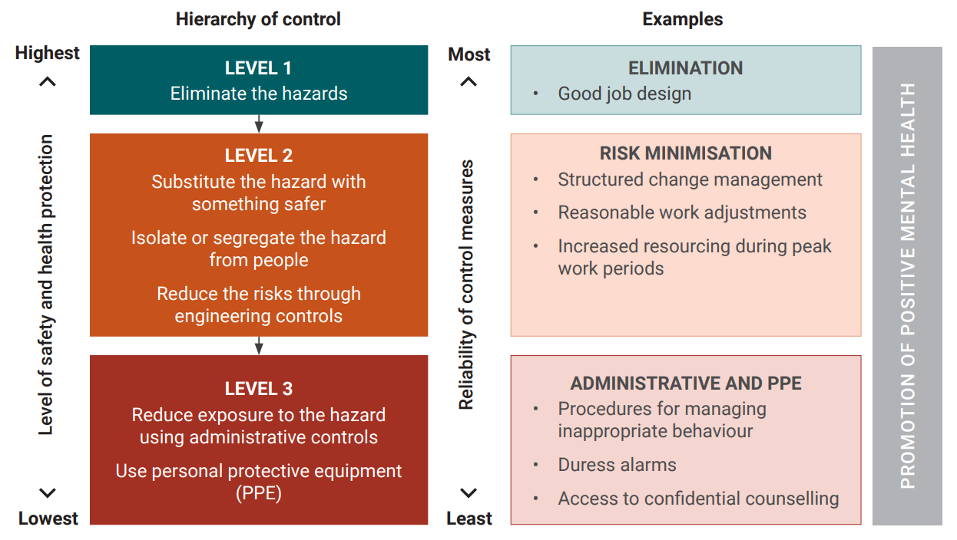
Figure 2.2 Hierarchy of control applied to psychosocial hazards and risk factors.

3 Leadership and workplace culture

3.1 Demonstrating commitment
Everyone contributes to the culture of their workplace, not only by what they say, but also by what they do. Effective leadership and a positive workplace culture set the tone for workplace relationships, and drive the allocation of resources to support effective implementation of preventative actions and controls.
A commitment to managing psychosocial hazards and risks by leaders and managers is essential for effective systematic health and safety risk management. To achieve this, they must understand:
            - the OSH obligations of the employer and workers
            - the role of leaders and managers to assist the employer to meet their OSH duties
            - systematic OSH management, including on psychosocial risks, and
            - the business case for OSH, including why managing psychosocial risks is a concern to your organisation.
An ongoing commitment from leaders that is visible across the workplace is a key factor for success. Leaders and others involved in management and supervision should model behaviours and interactions to encourage positive work practices and demonstrate to that it is important to appropriately identify and manage psychosocial risks.
Employers should have an overarching integrated work health and safety policy that includes identifying and managing psychosocial risks and hazards, and is appropriately supported and implemented across the workplace.

3.2 Supportive and capable management and supervision
Competencies shown to influence positive outcomes in the workplace are based on being respectful and responsible, managing and communicating existing and future work, leading teams, modelling desired behaviours and values, having difficult conversations and resolving conflict. Providing practical support, such as facilitating access to appropriate services and health management options such as recovery-at-work or return-to-work support, is a critical protective factor against harm to health from exposure to workplace psychosocial hazards and risk factors.
Respect is gained by having the knowledge, skills and support to be able to manage psychosocial hazards and risk factors, positively influence workplace culture, and address inappropriate behaviours and interactions with integrity and credibility. A willingness to listen to and respond to workers’ work health and safety concerns, and be engaged in a genuine dialogue about them, is fundamental to creating trust in working relationships.

3.3 Training and education
The employer must provide adequate and suitable information, training, instruction or supervision to workers (including supervisors and managers) which has regard to and includes:
- the nature of the work and tasks to be carried out by workers
- the psychosocial hazards and risks associated with the work
- the required control measures including safe systems of work and how to comply with these
- how workers should report and respond if a problem or risk arises, and
- ensure information, training and instruction is readily understood by any person it is provided to.
Uncertainty about how to safely and efficiently do new tasks including using new technology, or that may not have been undertaken for some time, or tasks undertaken during an emergency, and when working on unfamiliar worksites, are relatively common psychosocial hazards. Providing adequate and timely information, training, instruction and supervision are particularly important where the work has inherent risks (e.g. risk of violence for first responders).
In most cases, psychosocial risk management can use a mix of good work design, safe systems of work, and suitable and adequate information, training, instruction, and supervision.
Training and education may be required for leadership, as well as those with management and supervisory responsibilities, to achieve the desired competencies with the aim to effectively prevent and manage harm from psychosocial hazards and risk factors in the workplace.

4 Identifying psychosocial hazards and risk factors

4.1 Identification approaches
Undertaking a comprehensive risk assessment will help identify all foreseeable psychosocial hazards and risk factors. It may require input from operational groups (e.g. work teams, safety and health representatives) and subject matter experts where reasonably practicable (e.g. organisational psychologists, organisational development consultants, human resources consultants).
When starting the process, it is important to:
- identify who will take part (e.g. management, workers, safety and health representatives, subject matter experts, families, community representatives)
- gather workplace data that will inform the process (e.g. incident reports, complaints, absenteeism rates, baseline health data, survey results)
- understand legislative requirements and determine what the workplace is already doing to meet those requirements (e.g. policies, procedures, training)
- use a variety of sources (e.g. access online resources, engage a subject matter expert) to identify and understand the risk criteria
- consider how to maintain confidentiality and trust.
Psychosocial hazards and risk factors in the workplace may be identified in a variety of ways, including:
- reviewing organisational structure (e.g. lines of reporting, supervisory responsibilities)
- inspecting the condition of the physical workplace (e.g. equipment is working)
- assessing specific job requirements
- observing how work tasks are completed
- consulting with the workforce (e.g. safety and health representatives, focus groups, surveys) to help identify circumstances that could impact worker mental health
- reviewing investigation processes
- examining hazard and incident reports
- analysing human resources data such as absenteeism, exit interviews, staff turnover and complaints
- examining records of past incidents and injuries, including workers’ compensation claims, at the workplace
- examining data, where easily available, or published literature for similar workplaces
- consulting relevant codes of practice and other guidance
- analysing available de-identified data from work medical staff and employee assistance providers (EAPs).

5 Assessing the risks

5.1 Assessment approaches
Following the identification of psychosocial hazards and risk factors at the workplace, the next step in the risk management process is assessing the risks, which follows the same principles as the risk assessment undertaken for other hazards.
It is important those undertaking the risk assessment have access to information about the work environment and work processes, and knowledge and understanding of potential psychosocial hazards and risk factors. Assessments should:
- include data collection and monitoring of the controls (e.g. using workplace data and information from focus groups, interviews, de-identified surveys)
- involve consultation with safety and health representatives and committees
- cite the evidence used.
If those responsible for the risk assessment have limited knowledge and understanding about how to analyse the evidence, then appropriate training should be provided or assistance sought from a subject matter expert.
A risk assessment involves considering what could happen if a worker is exposed to a hazard and the likelihood of it happening. The assessment helps determine:
- who might be exposed
- the source of the risks
- potential interactions of multiple risk and protective factors
- how severe the risks are — the frequency and duration of potential exposure to a psychosocial hazard, possible consequences of exposure and likelihood of harm
- whether existing controls are effective
- what additional measures should be implemented to control the risks
- how urgently action needs to be taken.
Some hazards (e.g. bullying) and the associated risks they pose to psychological harm are well known, and have established and accepted controls. In these situations, formally assessing the risk is not necessary. After identifying a hazard, if the risks and how to control them effectively are already known, the controls may be implemented.
Workers may be exposed to more than one type of psychosocial hazard or risk factor at any one time. Psychosocial hazards and risk factors interact with each other so they should not be considered in isolation. For example, the combined effect of high work demands, low control, and low support increases the likelihood and severity of harm to a worker’s health. Conversely, high work demands with the control factors of good leadership and support can mitigate the negative impact on a worker’s health.
Employers should demonstrate that psychosocial hazards and risk factors have been considered and recorded as a part of their hazard identification and risk management process. The hazard and risk assessments should be reviewed and updated regularly, including when changes are made at the workplace.

Workplace behaviours
Inappropriate or unreasonable workplace behaviour can create a risk of harm to health and may include misconduct, prolonged conflict, discrimination, harassment, sexual harassment, and bullying. These behaviours could be conducted in person or through the use of technology (e.g. social media, emails, text messaging).
Considerations to support appropriate workplace behaviours include:
- development and maintenance of a positive workplace culture
- visible leadership commitment
- supportive work practices
- modelling of appropriate workplace behaviours by leaders and management
- fair and consistent implementation of policies and procedures, including standards of behaviour, reporting and responding to reports
- provision of regular training and information to all employees and management.
.

6 Risk control strategies

6.1 Control measures for psychosocial hazards
Every workplace is different. So, the best combination of control measures to eliminate hazards or minimise risks will be tailored to your organisation’s business size, type and work activities to manage risks during both everyday operations and emergencies.
Most effort should be on implementing control measures which target the psychosocial hazards identified and assessed in steps one and two. The risk controls can involve good work design across the organisation and/or be targeted to affected work groups and tasks with the highest risks.
Targeting controls in this way will provide the highest level of protection for the largest number of workers. These controls will usually also benefit individuals identified to be at risk of harm.

6.2 Eliminate or minimise risk through good work design
Elimination controls are the most effective control because they aim to eliminate the hazards and prevent harm to health. They should always be considered before other controls.
Where it is not reasonably practicable to eliminate the hazard, risks are addressed by risk minimisation and administrative and PPE controls. These controls are implemented with the aim of reducing harm to health.

Work design
Good work design is concerned with specifying and organising existing and new jobs and tasks of a workgroup (and if needed for individual workers) to be less hazardous. This will help meet organisational requirements to efficiently deliver services or products and assist in minimising harm from psychosocial hazards and risks.
Groups of workers may be exposed to several different kinds of psychosocial hazards and risks. The best and most effective way to control these is at the source, that is, by substituting the current work methods with less hazardous alternatives.
It may not always be reasonably practicable to eliminate the hazard or risk for example, where jobs have some inherent hazards such as shift work, or police dealing with violent or abusive members of the public. Or if by doing so you cannot make your product or deliver your service, or where the cost of implementing the control(s) is grossly disproportionate to the risk.
If a hazard or risk cannot be eliminated, then the employer must minimise it so far as is reasonably practicable.
When redesigning work, you can consider the psychosocial hazards identified and look for opportunities to turn these into controls to mitigate risk. For example, where there is role overload such as excessive time pressure, role conflict, and poor practical support you could improve scheduling to minimise overload, clarify roles and responsibilities and provide additional practical support.
Physical hazards contributing to psychosocial risks should be controlled through relevant isolation and engineering controls for example, the use of physical barriers to help control the risk of violence in the workplace.

6.3 Minimise risk through safe Systems of work
Employers have legislative obligations to provide a safe system of work in which workers are not exposed to hazards in the work environment as far as practicable.
Implementing a system of work that has a preventative focus reduces the likelihood of exposure to psychosocial hazards and risk factors in the workplace.
Safe systems of work are organisational rules, policies, procedures and work practices that must be developed and followed to ensure workers and others are not harmed by any remaining (residual) psychosocial risks. Systems of work may include rostering, working hours, task rotation and breaks to allow opportunities for rest and recovery, standards and procedures to manage hazardous tasks, and policies and procedures to manage workplace behaviour (such as bullying and harassment) or organisational codes of conduct.
Safe systems of work must be developed in consultation with workers and reviewed whenever there are changes to the work activities to ensure they remain appropriate.

Workplace behaviours
Inappropriate or unreasonable workplace behaviours are behaviours that can create a risk of harm to health and may include misconduct, unresolved conflict, discrimination, harassment, sexual harassment, and bullying. These behaviours can occur through various mechanisms including social media, mobile phone texting and SMS, email communication, telephone and in person.
Considerations to support appropriate workplace behaviours include:
- development and maintenance of a positive workplace culture
- visible leadership commitment
- supportive work practices
- modelling of appropriate workplace behaviours by leaders and management
- fair and consistent implementation of policies and procedures, including standards of behaviour, reporting and responding to reports
- provision of regular training and information to all employees and management.

6.4 Implementing controls
Because the controls you implement may require changes to the way work is carried out, it may be necessary to support these with:
- safe work procedure(s) that describe the tasks, hazards, how tasks can be safely done, and the duties, roles and responsibilities of all parties to follow these
- information, training, instruction and supervision of workers on implemented controls including safe work procedures
- appropriate information and instruction for site visitors
- a schedule for maintaining, monitoring and reviewing controls to ensure they are effective and are not creating new unintended WHS or organisational risk.
When proposing changes to existing or new controls or workplace arrangements, it is essential you consult affected workers and their HSR(s) as early as possible. For example, on the:
- design and management of the work such as restructures, work locations, changes to tasks, duties, and working arrangements
- new technology, plant, equipment production processes, or the redesign of existing workplaces.
Table 6.1 Some example control measures that may assist in developing and maintaining mentally healthy workplaces.
Control | Examples
Elimination
Eliminate exposure to psychosocial hazards, so far as is reasonably practicable | Address psychosocial hazards and risk factors at their source by:  - applying principles of good job design  - clearly defining job roles, reporting structures and activities  - establishing achievable workloads and performance targets that match resources (e.g. number of workers, skills mix, fit-for-purpose equipment)  - maintaining a workplace culture that is knowledgeable about psychosocial hazards, risks and controls, and encourages help-seeking behaviour  - providing access to reliable communication infrastructure and supportive technology  - using online systems instead of in-person services
Risk minimisation
Reduce likelihood and severity of harm from exposure to psychosocial hazards and risk factors | Minimise harm by:  - educating leaders on  - how they influence the development and maintenance of a mentally healthy workplace  - control strategies and their implementation  - implementing a structured change management process, including consultation with workers, for significant organisational changes  - supporting engagement with family and social networks  - providing workers with control over the order and pace of jobs  - rotating jobs for repetitive or highly demanding tasks  - adjusting workloads  - modifying the built environment to address environmental factors (e.g. soundproofing, thermal comfort, adequate lighting)  - providing sufficient resources to complete the job safely and on time  - minimising role confusion by clearly defining workers’ tasks, duties and performance standards  - increasing practical and emotional support during peak work periods  - monitoring peak workloads and rostering additional workers during peak work periods  - making reasonable work adjustments  - facilitating the reporting of psychosocial hazards (without fear of negative consequences)
Administrative and PPE
Address adverse health effects from exposure to psychosocial hazards and risk factors | Address adverse health effects from exposure to psychosocial hazards and risk factors by:  - having policies and procedures  - for timely welfare checks when workers do not report to work or are missing from work  - to manage and respond to critical and traumatic events  - supporting diversity and inclusion  - facilitating the reporting of incidents  - investigating injuries, incidents and complaints, and communicating remedial actions to the worker and workplace as appropriate  - educating and informing workers on  - healthy coping strategies  - accessing supporting resources (e.g. support programs)  - identifying the early signs of distress and what to do  - supporting access to health professionals and confidential counselling  - providing access to an employee assistance program (EAP) for work and non-work concerns  - having emergency response and crisis management plans that address mental health scenarios, including suicidal behaviour  - having maintain-at-work and return-to-work programs  - providing individual skills training (e.g. conflict resolution)

7 Review
The review process is used to confirm that control measures are working as expected, and checking that other hazards and risk factors have not been introduced when implementing or modifying controls.
The results of monitoring for psychosocial hazards and risk factors are used:
- for verification and validation of controls
- to identify learning opportunities for the purpose of continuous improvement.
The monitoring results should be used during the review to trigger corrective measures, including early intervention if necessary.
Mechanisms for the recognition and early detection of harm to mental health in the workplace include analysing workplace data from:
- hazard, incident and investigation reports
- complaints
- worker surveys
- consultation with safety and health representatives and work teams
- alcohol and other drug test results
- direct observations (e.g. workers displaying the early signs and symptoms of psychological or physical harm).

9 Responding to worker reports
There are various ways in which workers report exposure to psychosocial hazards or risk factors to their employer. Addressing these reports helps to achieve safer and healthier workplaces.
Examples of types of reporting include:
- verbal discussions
- hazard or incident report forms
- letters of complaint or grievance
- emails
- medical certificates
- workers’ compensation claims
- text messages.
It is important that the person receiving the report communicates with the individual or group of workers about how they intend to address it, which may be an informal or formal process. Keeping people updated about the progress of their report also helps to establish trust and encourages a reporting culture.
If a formal process is conducted, those undertaking the investigation should be competent in identifying psychosocial risk factors, hazards, sources of risk, and appropriate preventative control measures. As investigations into psychosocial risk factors and hazards can be complex, input from subject matter experts (e.g. organisational psychologists, organisational development consultants, human resources consultants) may be required.
Consultation with safety and health representatives and affected workers is important. However, it will not always be appropriate to consult with safety and health representatives if the initiating report or subsequent investigation includes sensitive and confidential information about other workers.
Key steps in the process for investigating and responding to reports of psychosocial hazards and risk factors are:
- identifying contributing psychosocial risk factors – organisational, environmental and individual
- identifying sources of contributing psychosocial risk factors
- identifying existing control measures and their adequacy
- identifying preventative control measures
- implementing preventative control measures
- reviewing and monitoring.

Appendix 1 Legislative provisions

Occupational safety and health legislation
The current mining, petroleum and general industry legislation does not include a definition of ‘health’ and does not explicitly cover mental health. However, the Department of Mines, Industry Regulation and Safety considers the intent of the legislation, and interprets ‘health’ to mean physical and psychological (mental) health.
The parts of occupational safety and health legislation administered by the Department that may be applicable to this code of practice are listed below.

Occupational Safety and Health Act 1984

Part III, Division 2 – General workplace duties
s. 19 Duties of employers
s. 20 Duties of employees
s. 21 Duties of employers and self-employed persons
s. 22 Duties of persons who have control of workplaces
s. 23 Duty of employer to maintain safe premises

Occupational Safety and Health Regulations 1996

Part 3, Division 1 – General duties applying to workplaces
r. 3.1 Identification of hazards, and assessment and reduction of risks, duties of employer etc. as to

Other legislation to consider
- Equal Opportunity Act 1984
- Fair Work Act 2009 (Commonwealth)
- Industrial Relations Act 1979
- Privacy Act 1988 (Commonwealth)
Note: The only authorised versions of the Act and regulations are those available from the Department of Justice (www.legislation.wa.gov.au), the official publisher of Western Australian legislation and statutory information.

Appendix 2 Examples of risk management in various workplaces

The following examples show how the risk management approach can be applied to psychosocial hazards and risk factors in a variety of workplaces.
These are examples only and may not address all the psychosocial hazards and risk factors at a workplace. A combination of controls may be required, depending on the circumstances of individual workplaces.
The level of detail provided should be appropriate for the risk profile (e.g. hazards, workforce characteristics, services provided), size and complexity of the business.

Hazard identification and risk assessment form (small – service/retail)
The following example reflects a range of psychosocial hazards, risk factors and controls in a small hairdressing salon.
Risk factors | Risk control | Person responsible
Work demands – fast pace, time pressure | - Establish achievable performance targets and expectations in consultation with staff  - Monitor peak workloads and roster additional staff during peak work periods  - Match clients’ needs to staff skill sets whenever possible  - Check that staff are able to manage their workload in the time allocated and adjust if necessary  - Ensure that staff get adequate breaks throughout the day  - Roster staff so that all full time staff get regular two-day breaks | Owner  Owner  Owner, Senior Stylist  Owner, Senior Stylist  Owner, Senior Stylist  Owner
Work demands – repetitive or monotonous tasks | - Ensure that staff have a variety of tasks to complete throughout the day | Owner, Senior stylist
Inadequate support | - Promote an inclusive environment  - Provide one-on-one supervision of junior staff  - Hold weekly team meetings to facilitate consultation  - Provide adequate support for junior staff when they have difficult clients | Owner, Senior Stylist
Low recognition and reward | - Provide positive feedback on job and task performance  - Offer growth and development opportunities  - Encourage attendance and networking at industry events | Owner, Senior Stylist
Adverse environmental conditions | - Use air conditioning to counteract heat generated by salon equipment  - Ensure that salon and adjoining rooms have adequate ventilation  - Reduce noise levels by managing acoustics and using quieter equipment  - Provide appropriate PPE (e.g. gloves, masks) | Owner
Inappropriate behaviours | - Have a clear policy for acceptable behaviour of staff and clients  - Have a procedure for managing complaints and conflict  - Seek external help if a matter cannot be dealt with internally  - Allow flexibility for staff to seek medical assistance or support if required  - Have a clear policy on drugs and alcohol  - Educate staff on healthy coping strategies and accessing supporting resources (e.g. support programs, online resources) | Owner

Hazard identification and risk assessment form (medium – medical centre)
The following example reflects a range of psychosocial hazards, risk factors and controls in a medium-sized medical centre. The centre offers the full range of general practice (family and occupational medicine), with doctors specialising in mental health and addiction services. The services are provided in-person, after hours (locum service) and via telecare.
Risk factors | Risk control | Person responsible
Work demands – fast pace and time pressure, excessive workload | In consultation with practice doctors:  - build in time between appointments to allow for doctors to catch up  - schedule time for paperwork, consultation with specialists and research  - check that patients select appropriate appointment length for the complexity of their health issues  - refer patients to a practice nurse where appropriate  - establish rosters and ongoing availability, including coverage for personal and annual leave  - set up rosters for Saturdays and locum services  For office staff:  - roster extra staff to cover peak periods (e.g. Monday morning)  - create a temporary staff pool to cover staff absences such as leave  - offer patients the option to book online | Practice Manager
Burnout | - In consultation with staff, develop a case allocation system based on triaging, with distribution of complex cases monitored and reviewed  - Incorporate fatigue management into rosters and work practices to allow for adequate rest and recovery  - Provide training on recognising signs and symptoms of burnout and promoting early intervention  - Provide training on decreasing stigma around help-seeking behaviour  - Provide peer support and debriefing  - Facilitate access to mentoring and peer supervision for doctors  - Support access to confidential counselling  - Provide access to an employee assistance program for work and non-work concerns  - Refer staff to advice and support services available for medical practitioners | Practice Manager
Vicarious trauma | - Provide pre-employment information on the type of situations that may arise on the job  - Support access to confidential counselling  - Provide opportunities for peer support and debriefing  - Facilitate access to mentoring and peer supervision for doctors  - Provide training on behavioural techniques that reduce the body’s physiological response to other people’s traumatic experiences  - Provide psychosocial education about common signs and symptoms of vicarious trauma and promote help-seeking behaviour  - In consultation with staff, adjust workloads to facilitate recovery at work | Practice Manager
Inappropriate behaviours | - Have a clear policy for acceptable behaviour of staff and patients  - Have a procedure for managing complaints  - Have a notification process for workers of clients or patients who have previously exhibited inappropriate behaviour  - Seek external help if a matter cannot be dealt with internally  - Have a clear policy on drugs and alcohol  - Publicise relevant policies and procedures online and on signs in the practice waiting rooms | Practice Manager

Hazard identification and risk assessment form (medium – automotive workshop)
The following example reflects a range of hazards and risk factors and controls in a medium-sized automotive workshop.
Risk factors | Risk control | Person responsible
Poor leadership practices and workplace culture | - Develop a consultative leadership style  - Ensure that there is visible leadership support and modelling of appropriate workplace behaviours by leaders and managers  - Develop an inclusive working environment  - Consult workers when making decisions that affect their working environment | General Manager, Workshop Manager, Office Manager
Poor organisational justice | - Ensure that policies and procedures are applied consistently and fairly  - Ensure that meaningful work is distributed fairly  - Ensure that decisions about work-related entitlements and opportunities are transparent and communicated | General Manager, Workshop Manager, Office Manager
Poor or no workplace policies and procedures | - Have a clear policy for acceptable workplace behaviours  - Have a procedure for managing complaints  - Provide training and information to management and workers on acceptable workplace behaviours and conflict resolution  - Seek external help if a matter cannot be dealt with internally  - Ensure policies and procedures are accessible (e.g. lunch room, notice boards, reception area) | Workshop Manager, Office Manager
Lack of role clarity | - In consultation with workers, establish clear position descriptions  - Establish clear processes for work flow, responsibilities and reporting lines  - Hold daily toolbox meetings to discuss tasks and work allocations  - Provide an appropriate level of supervision to ensure workers have a clear understanding of their duties and performance expectations | Workshop Manager, Office Manager
Adverse environmental conditions | - Reduce noise levels by managing acoustics and using quieter equipment  - In consultation with staff, consider and manage other background noise i.e. radios, mobile phones  - Ensure workshop areas have adequate ventilation and temperature control  - Provide appropriate PPE (e.g. hearing and eye protection, gloves; comfortable, fit-for-purpose clothing) | Workshop Manager

Hazard identification and risk assessment form (large – State Government department)
The following example reflects a range of hazards, risk factors and controls in a State Government department.
Staff profile: State Government department employing 5000 workers in a range of roles including office-based and field work.
Hazard: Work-related stress
Risk factors | Risk control | Person responsible
Poor leadership practices and workplace culture | - Implement an organisation-wide strategy to create a mentally healthy workplace which includes cultural change to address leadership styles, psychological safety in reporting, positive workplace behaviours and management accountability  - Provide coaching to modify behaviours to improve leadership and management skills in conflict resolution, performance development and management, and provision of practical and emotional support  - Ensure training in workforce diversity and inclusion is embedded in recruitment and selection processes as well as promotion  - Implement key performance indicators for any positions that have responsibility for other staff relating to contributing to a positive workplace culture  - Offer a range of flexible work practices to allow staff to manage work and personal needs, while maintaining operational needs | Director
Poor organisational justice | - Ensure that policies and procedures are applied consistently and fairly  - Ensure that meaningful work is distributed fairly  - Ensure that decisions about work-related entitlements and opportunities are transparent and communicated | Director, Team Leader, Human Resources Manager
Work demands – high volume, time pressure, emotionally demanding work | - Set achievable performance targets for current staff numbers and mix  - Clarify workers’ roles and responsibilities through position descriptions  - Establish clear processes for work flow  - Review resourcing and staff mix of skills to ensure there is adequate resourcing and skills to manage work demands  - Establish achievable performance targets and expectations in consultation with staff  - Monitor peak workloads and roster additional staff during peak periods  - Ensure that staff get adequate breaks throughout the day | Team Leader, Human Resources Manager
Poor organisational change management | - Implement a structured change management process to ensure all changes are communicated to affected workers, and workers are consulted about the proposed change and process | Director, Human Resources Manager
Inappropriate behaviours | - Train workers, managers and supervisors in addressing and identifying inappropriate or unreasonable workplace behaviour  - Integrate the code of conduct into staff communications and forums to ensure the promotion of the code of conduct has occurred across all levels of the organisation  - Appoint grievance officers and promote the grievance process | Human Resources Manager
Inadequate support | - Provide practical resources and emotional support that match the demands of the work and workers’ needs  - Provide training to recognise signs and symptoms of distress and promote early intervention  - Promote positive attitudes to mental health through the provision of programs that destigmatise mental health conditions and encourage help-seeking behaviour  - Provide peer support and debriefing for client facing roles  - Support access to confidential counselling  - Provide access to an employee assistance program for work and non-work concerns.  - Provide ongoing constructive feedback from direct line managers  - Provide positive encouragement to help workers maintain their motivation and engagement in achieving milestones | Director, Team Leader
Low recognition and reward | - Establish a system for professional development advancement opportunities with clear criteria  - Recognise achievements on an individual and team level  - Acknowledge and recognise workers demonstrating appropriate workplace behaviours or organisational values | Director, Team Leader, Human Resources Manager

Adapted from SafeWork NSW, Managing Psychosocial Hazards at Work (2021)
Adapted from SafeWork NSW, Managing Psychosocial Hazards at Work (2021)

